Name: Penumudi Tarun Sai Phanindra
Reg ID: 12306985
Section: KM059
Roll: 9

INT 330-MANAGING CLOUD SOLUTIONS

CA 2: PROJECT

Designing a Simple AWS Architecture.
Description:
This project involves building a basic Movie Trailer Streaming Platform using AWS services. The platform allows admin to upload, store, and stream movie trailers efficiently. Amazon S3 is used for storage, while Amazon CloudFront delivers fast streaming. Amazon SNS is used to notify users of new uploads. The system is scalable, reliable, and cost-effective, ensuring smooth performance with minimal latency.

Essential AWS Services used:
- Amazon S3: For scalable and durable storage of movie trailer files.
- Amazon CloudFront: To deliver content with low latency and high transfer speeds globally.
- Amazon SNS: To send notifications to users about new uploads and updates.
- IAM: To manage secure access and permissions for AWS services.
- SNS Topic: To facilitate event-driven notifications when new content is uploaded.

EXAMPLE

Scenario:
An admin uploads movie trailers in high-definition format to a cloud storage system. The goal is to enable efficient streaming by storing these trailers in a secure and scalable way. The system should automatically notify relevant services when new content is uploaded, triggering event-driven workflows. These workflows ensure that the trailers are available for streaming and accessible across different devices, ensuring optimal user experience with minimal latency.

Problem Statement:

Design an AWS-based serverless movie trailer streaming platform that ensures seamless, scalable, and cost-efficient storage and delivery of high-definition movie trailers. The system should automatically handle trailer uploads, provide event-driven notifications, and enable easy access for users to stream trailers with minimal latency and optimized performance.

Objectives:
- Seamless Movie Trailer Uploads: To enable the admin to easily upload movie trailer files to an Amazon S3 bucket for storage.
- Efficient Data Storage: To utilize Amazon S3 for storing movie trailers securely, with options for managing access through IAM roles and policies.
- Cost-Effective Solution: To create an architecture that minimizes costs by utilizing serverless services such as S3, SNS, and event-driven architecture.
- Reliable Streaming and Delivery: To ensure the movie trailers are optimized for streaming, with low latency and high availability.
- Automatic Event Notifications: To set up SNS for notifying the admin about specific events (such as successful uploads) related to the movie trailer files.
- Scalable Architecture: To ensure the solution can scale as more trailers are uploaded and accessed, using AWS services like SNS, S3, and CloudWatch.

- Outcomes:

- Automated Movie Trailer Uploads: Movie trailers are automatically uploaded to S3 when the admin uploads them, triggering SNS notifications.
- Scalability: The system can handle multiple movie trailer uploads concurrently without downtime, leveraging AWS's event-driven architecture.
- Cost Optimization: By utilizing serverless services like SNS, S3, and CloudWatch, the solution reduces operational costs associated with infrastructure management.
- Fast Delivery via CloudFront: Movie trailers are delivered with low latency and high performance using CloudFront, ensuring seamless streaming experience for users through optimized content delivery.

5. Proposed AWS Components:
- Amazon S3: Stores movie trailers (video files) uploaded by the admin.
- Amazon CloudFront: Distributes movie trailers globally, ensuring low-latency streaming to end-users.
- Amazon SNS: Sends notifications (like email) when new movie trailers are uploaded.
- AWS IAM: Manages secure access permissions for all AWS services involved (S3, CloudFront, SNS).
- Amazon S3 Event Notifications: Triggers SNS notifications whenever a new trailer is uploaded to the S3 bucket.

Implementation 1: Traditional Server-Based Approach:

1. Setup S3 Buckets
- Go to AWS S3 Console.
- Create two buckets:
- movie-trailer-website-123 - Hosts the static website (HTML) for the movie trailer streaming platform.
- Upload Index.html file and enable static web hosting.
- movie-trailer-videos-123 - Stores the actual movie trailer video files and Thumbnails uploaded by the admin.
Upload Movie Trailers and Thumbnails in this Bucket.
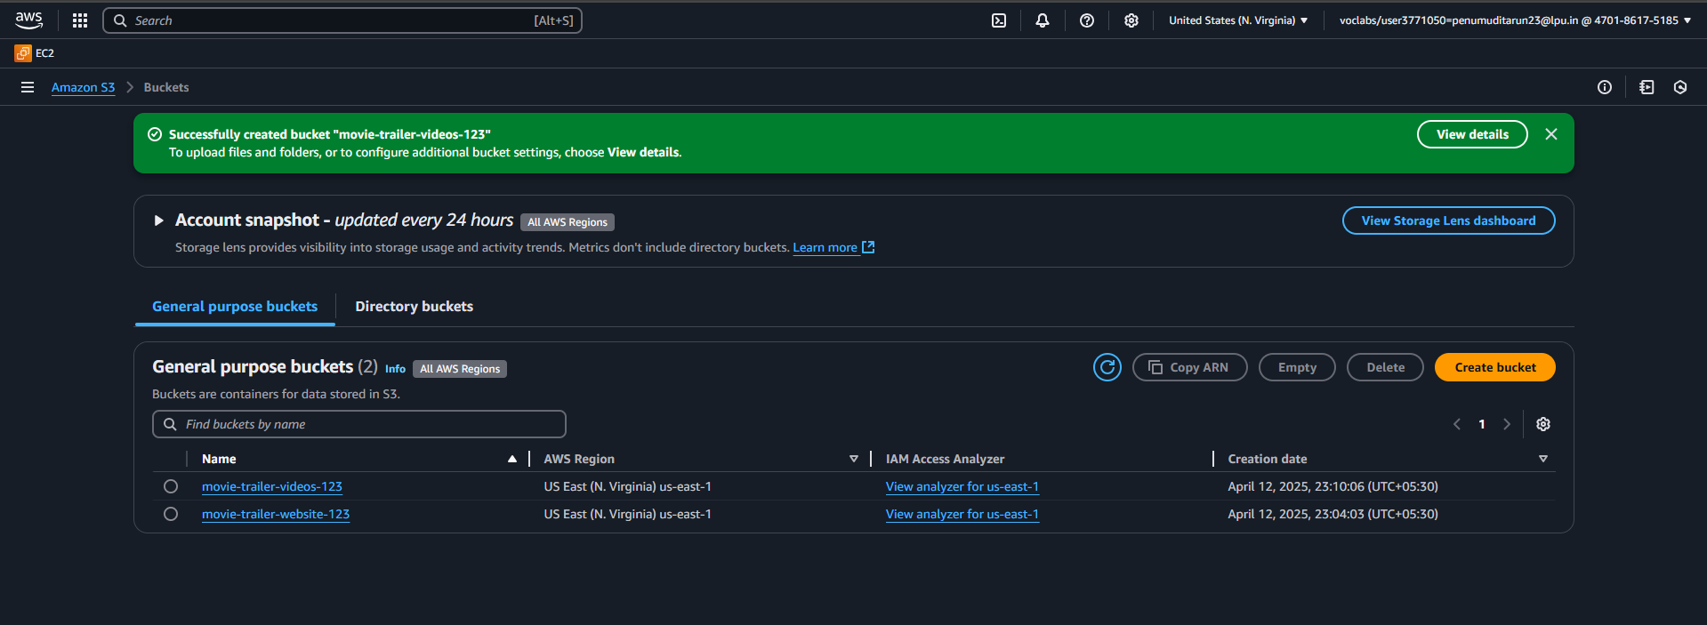
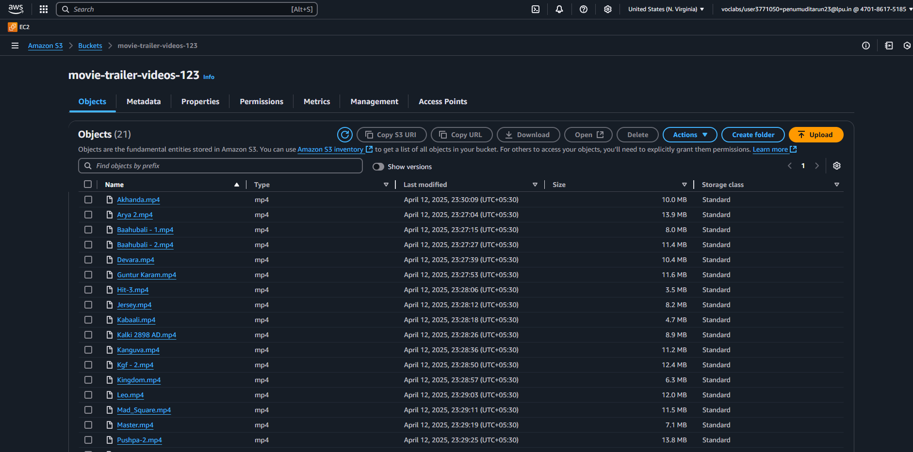

CloudFront delivers our movie trailers and website content faster by caching them at global edge locations. It also adds a secure and reliable layer for accessing S3-hosted files.
2. Create a Distribution in CloudFront:
- Go to AWS CloudFront and then create a new Distribution.
- Give it a name and select website bucket as origin domain
- For viewer protocol policy: HTTP to HTTPS for secure delivery
- Set index.html as default root object
- Then create Distribution hence extract Domain name for global search
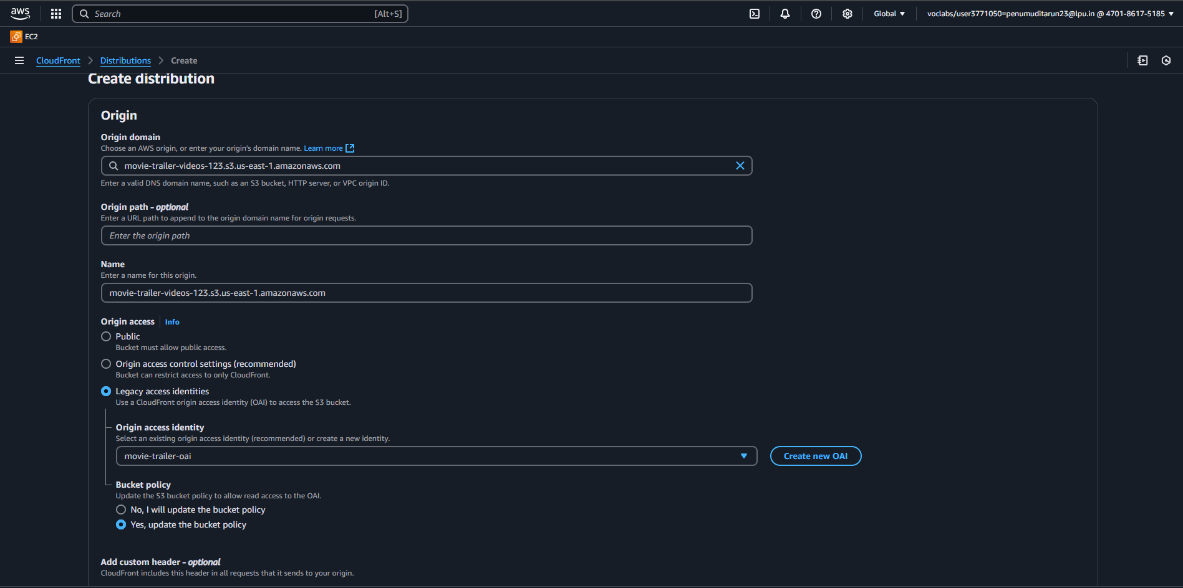

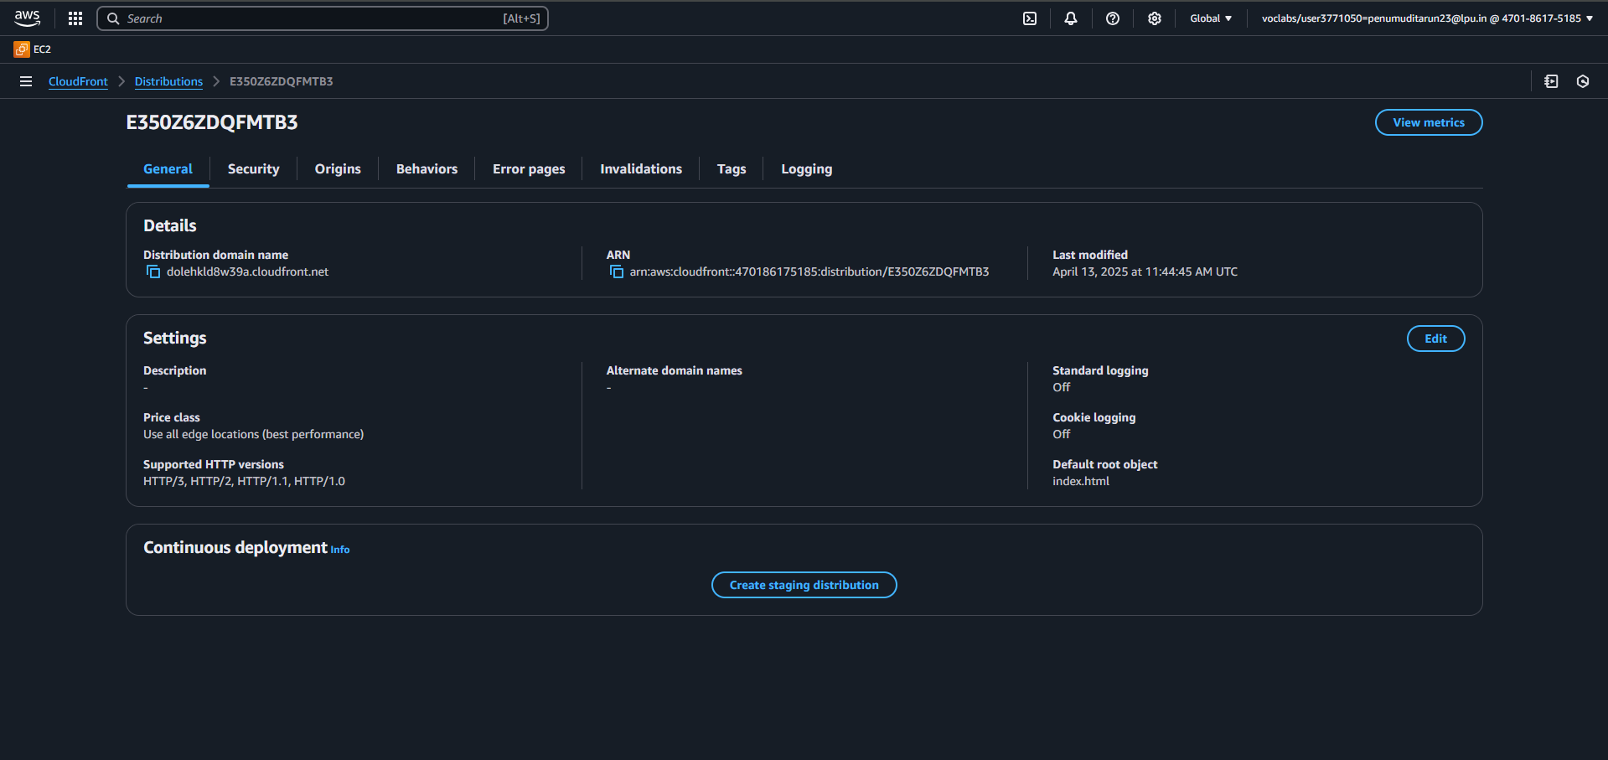

3. Create SNS Topic:
- Go to AWS SNS TOPIC and create Topic.
- Subscribe an Email by entering admin’s email address
- Connect SNS to S3 bucket
- Save the notification configuration.
- Create Event Notification.
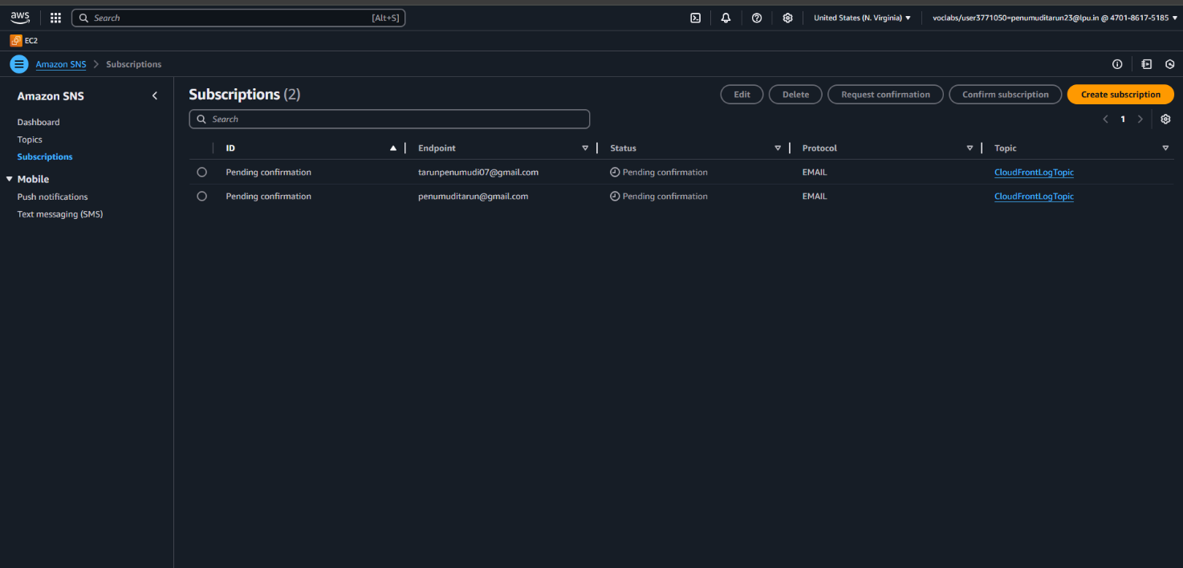
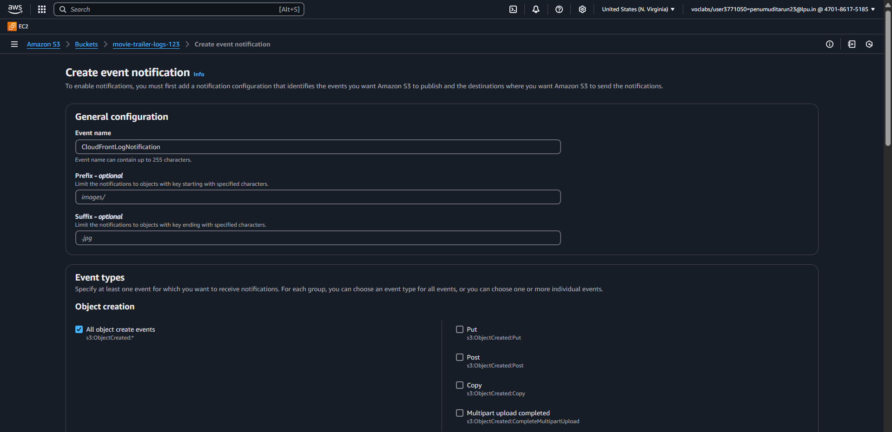

Cloud Watch: When we set up SNS notifications from S3, CloudWatch automatically tracks events like object creation.
4.Create Cloud watch for Monitoring:
- Navigate to logs and log groups.
- Select SNS as log group.
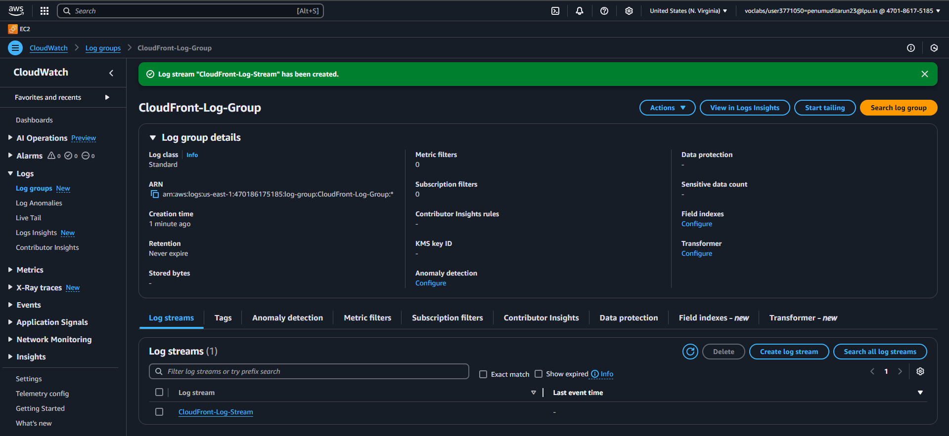
5.Static Webpage: (To stream Admin uploaded Trailers)
- User is able to watch Trailer.
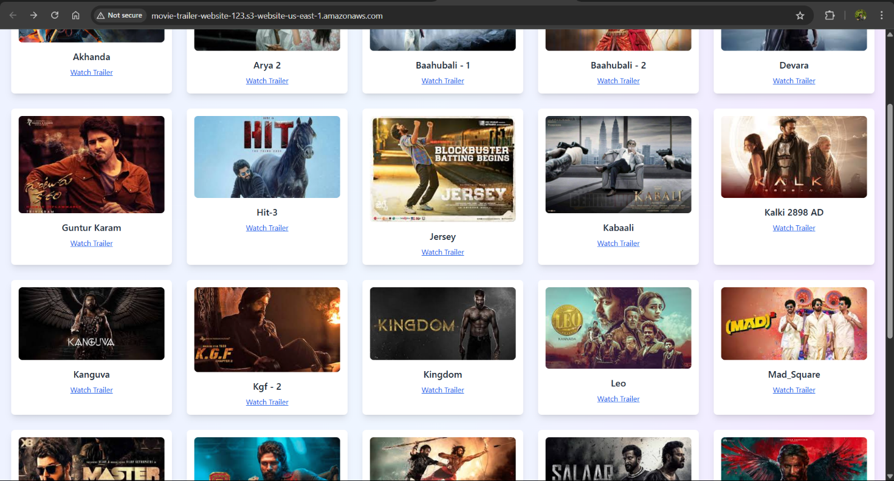
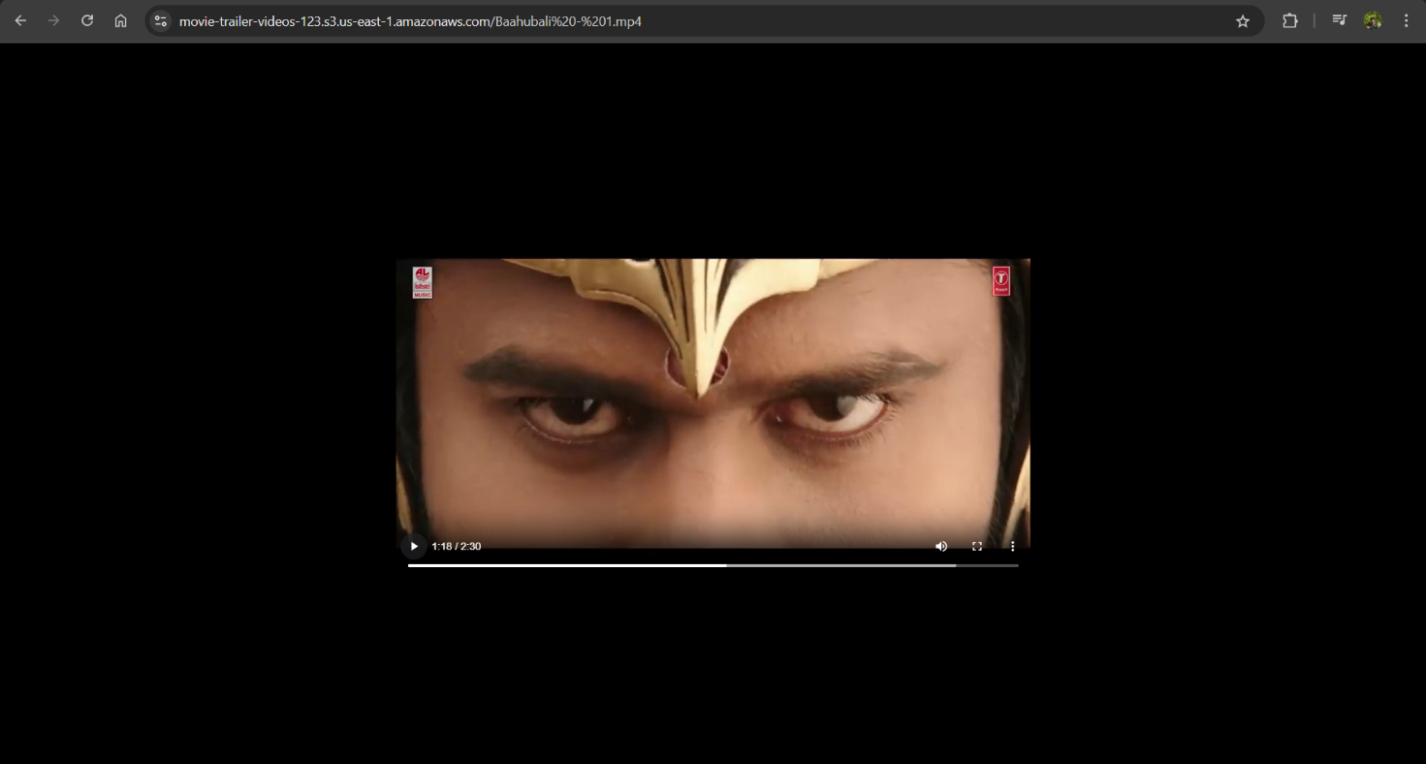

- Rubrics for Evaluation:
Criteria | Description | Marks(Total -100)
Implementation | Scalability:Evaluate the system's ability to scale dynamically during traffic spikes without downtime. | 0-15
 | Availability : Assesses uptime and fault tolerance, ensuring consistent operations during campaigns. | 0-15
 | Security Measures: Evaluate the implementation of security measures to protect against potential threats. | 0-10
 | Performance: Measure the speed, response time, and low latency of the application during high traffic. | 0-10
 | Monitoring & Cost Mgmt.: Evaluate and monitor how well resources are optimized to balance performance and cost. | 0-10
Documentation | Evaluate the clarity, completeness, and technical soundness of the architecture documentation. | 0-15
Presentation | Evaluate how clearly the presenter conveys the information, ensuring the audience understands the architecture and concepts. | 0-25

